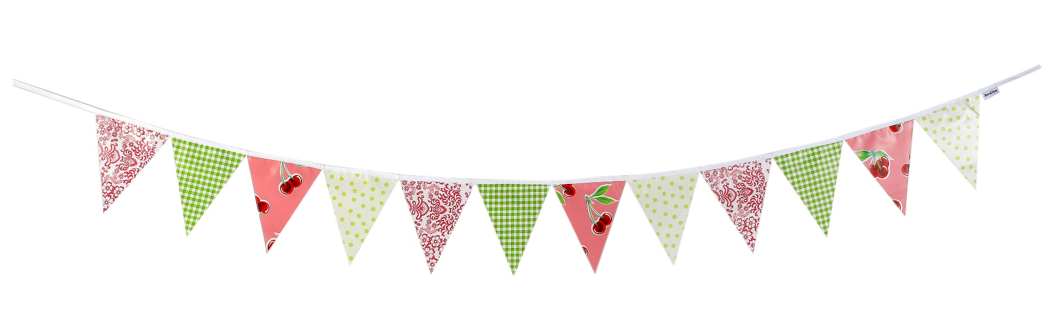

GHASA Spring Term Newsletter

GHASA have had a very successful term. Following on from the success of last terms events we have started to see the rewards from all the fundraising which has already taken place.

So far GHASA have funded;

* A new bike shed for Ash
* Coaches for all the school trips
* Christmas Lunch trimmings

And finally, we have exceeded our target and have already provided the school with 3 of the 5 smartboards that the school wanted in each of the classrooms. We fully expect that, by the end of the year, the other 2 smartboards will have been ordered and put to use within the school.

We would like to say a massive THANK YOU to all the parents who have helped support us already this year. The cake sales, the bonfire night, the Christmas café and all the raffles … they all contribute to the GHASA fund which in turn is helping fund things for our children. The money raised is vital for the school as it funds school trips and other welfare/educational activities.

This year Harjit, our GHASA Chair, is sadly stepping down from her position. Harjit has been a wonderful chair and member of GHASA and has supported the school in so many ways. She has given up many hours and her support will be greatly missed. It does mean that there will be some reshuffling on the committee. We are always, always, ALWAYS, appreciative of any help and support from parents and would like to invite anyone who has an interest in GHASA to attend our AGM meeting. It will be held at school on FRIDAY 26th APRIL at 15.30

A few dates to pop into the diary:

Sycamore Cake Sale 26th April

Ash Cake Sale 24th May

AGM 26th April

We are also starting to think about our next big fundraising event; the Gomeldon School Summer Fete. If anyone is able to lend a hand… even for just a few hours please make yourself known. Any help is welcome.

ENJOY THE SPRING BREAK, Happy Easter from the entire committee.