

Gomeldon Primary School

Gomeldon
Salisbury

Wiltshire
SP4 6JZ
Telephone: 01980 611370
Email: admin@gomeldon.wilts.sch.uk
26th April 2024
School Value of the term: Resourcefulness

This week’s menu: 3
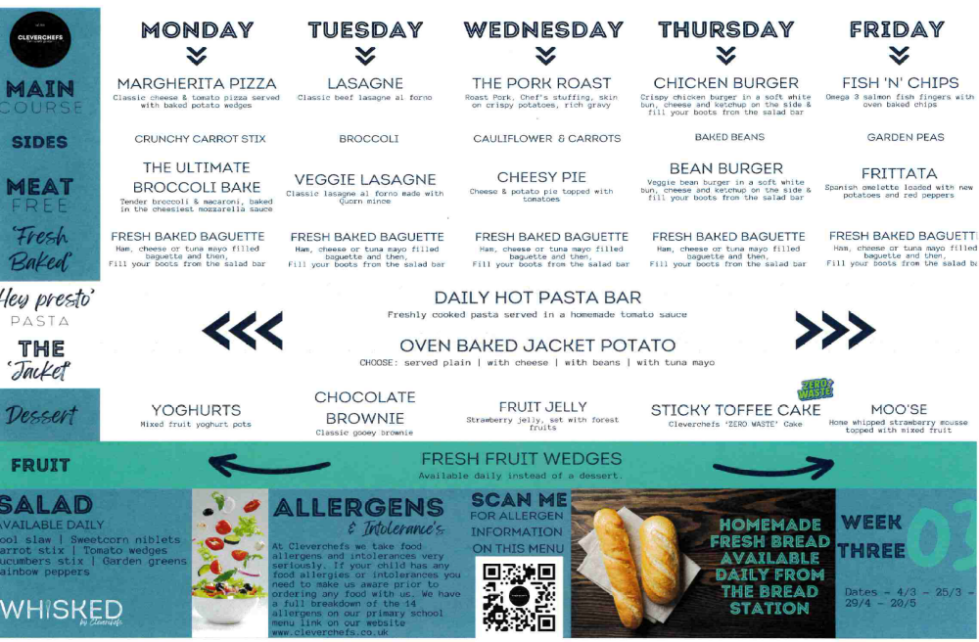

This week we celebrate the following Stars of the Week:
Ash Class: Eryk for brilliant independent Maths work!
Oak Class: Yumeth for effort and perseverance in phonics and writing.
Beech Class: Polly for being a kind, supportive friend to others.
Chestnut: Thomas for good focus and effort during English sessions.
Sycamore Class: Caleb for showing fantastic focus and understanding in algebra work.

TD days
I can confirm that the following dates will be the TD dates for next school year. There is one more to follow which I am hoping to be able to confirm as soon as possible:

2nd September 2024
23rd october2024
14th February 2025
24th July 2025

Julia’s Hospice – Teddy Bear Picnic
We are taking part in the Big Teddy Takeover again! Bring your favourite teddy and £1 to school to raise money for Julia’s House Children’s Hospice in June. (Date to be confirmed).
As you know, Julia’s House cares for the most critically ill children across Wiltshire and Dorset. They are a charity and rely on donations to provide practical and emotional support for families caring for a child with a life-limiting or life-threatening condition. They provide frequent and regular support in homes, in the community or at hospices. We are happy to support this worthy cause.

Phonics Workshop
A reminder that we are looking forward to welcoming you to school on Monday at 2:30pm for our phonics workshop for parents with Miss Higginbottom. If you are able to join us, do bring along the resources that went home with children in Ash and Oak Class

After School Clubs
We’ve had a super start to our new after school club. A reminder please to ensure you book both sessions if children are staying after a sports club. Also, please ensure that you have booked your child into the club before 3pm on the day of the required session. If you haven’t booked by this time there may be a risk that your child will not be able to attend. Whilst we continue to get used to new systems, please do not hesitate to make contact with the school office who can help you with this.

Attendance
You may shortly receive a letter about your child’s attendance at school. Following a supportive meeting with our school EWO (Education Welfare Officer) we have been closely tracking the attendance of children at school. Where attendance drops below certain levels we are required to contact families. We may be in shortly in the form of phone calls and letters – please be reassured that this is aimed at being supportive in helping families ensure children attend school.

Best wishes,
Catherine Windross

CHILD PROTECTION STATEMENT
At Gomeldon Primary School, we are committed to safeguarding and promoting the welfare of children. We work together following the Safeguarding and Child Protection Policy to ensure this, respecting all members of the school’s community and treating information with confidentiality.

Gomeldon Diary Dates
*Please note that some dates may be subject to change*

School TD Days: 03/06/24

Additional Dates in BOLD.

29th April | Phonics workshop 2:30pm
13th May | SATs Week for Y6
13th May | Ash Class Assembly 2:30pm
13th May | Parent Meeting for Avon Tyrrell
18th May | Salisbury Mini-Marathon
20th May | Parent Celebration Assembly – invite only
3rd June | TD Day – School closed for children
6th June | Sports Day
10th June | Oak Class Assembly
12th – 14th June | Avon Tyrrell Residential trip for Year 5 & 6
18th June | Open afternoon 2:30pm
18th June | ‘Meet the teacher’ presentations 3:40pm & 4:15pm
24th – 25th June | Bikeability 1
26th – 27th June | Bikeability 2
15th July | Parent Celebration Assembly – invite only
22nd July | Year 6 Leavers Assembly 2:30pm
23rd July | Whole School End of Year Treat.

